**Good News Ambassador**

**February 2023**

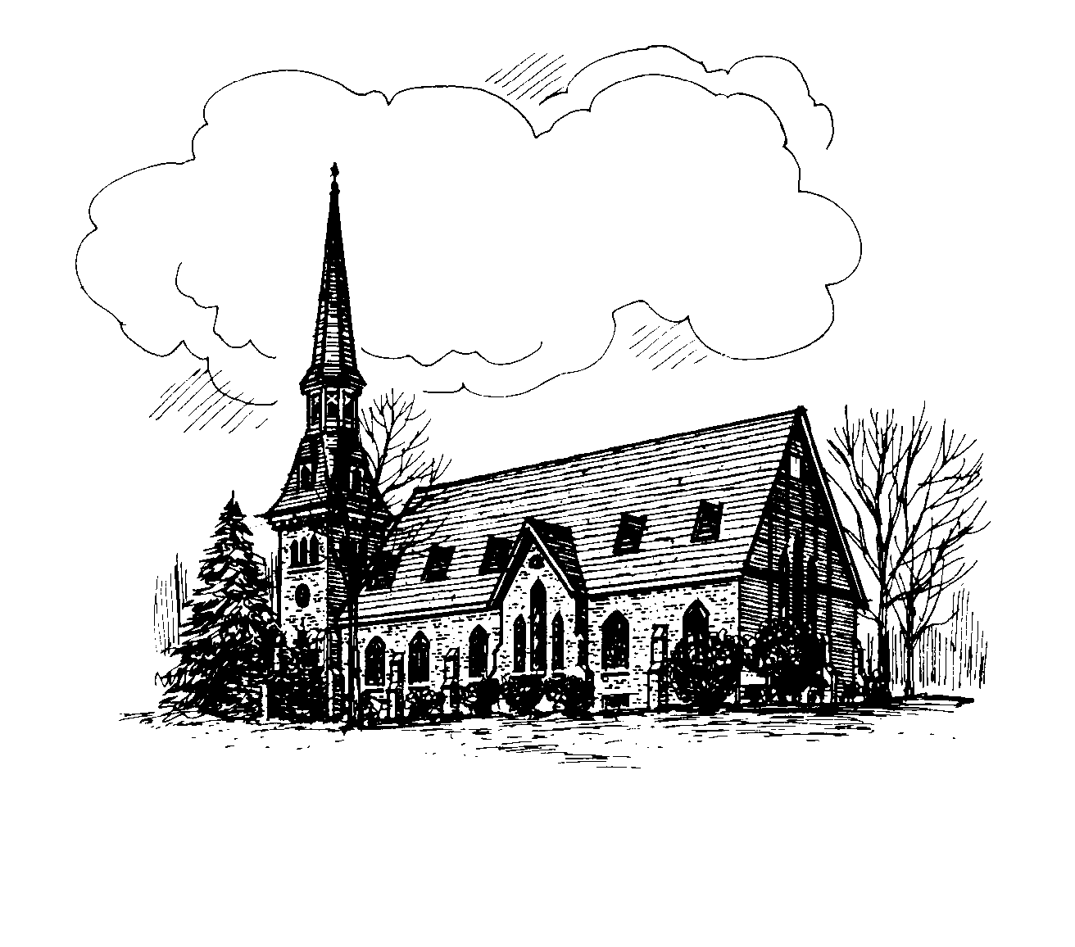

**CHURCH OF CHRIST UNITING**

A Congregation of the Presbyterian Church

and the

United Methodist Church

The Reverend Casey Bradley, 315 858 8864

Alice Mahardy, Organist & Choir Director

PO Box 896, Richfield Springs, NY 13439

**Online and In-person Worship**

Join us **Sundays at 9:15 am.** All in-person worship services will be livestreamed to our church

**Facebook** page: **RS Church of Christ Uniting**

Go to [www.facebook.com](http://www.facebook.com) and put the above name in the search, or watch later on **YouTube**, by searching on **RS COCU**.

[www.rschurchofchristuniting.com](http://www.rschurchofchristuniting.com)



**PASTOR’S MESSAGE**

It’s hard to believe that Lent is almost here. There’s something kind of fascinating about the way that Lent can catch us off guard. There is a bit of uncertainty around this season that I think is emphasized by the fact that Lent doesn’t always begin on the same day each year. Of course, the day Lent begins is no mystery; Lent begins 46 days before Easter and Easter begins on the first Sunday after the first full moon that occurs on or following the spring equinox. This year Lent begins with Monday, February 13, at 6:30 p.m. Ash Wednesday on February 22nd. The quasi-uncertainty of

Lent resonates with our church theme this year; we are focusing on where we are going in the midst of all the uncertainties of life.

We begin our Lenten journey with ash, a reminder of the fragility and mortality of life. We take the fronds from Palm Sunday, reduce them to ashes, and share them as a reminder that we live in the realm of mortality. Lent will end on a Saturday night when stillness covers the earth and reminds us of the emptiness of our lives outside of Christ Jesus. In between Ash Wednesday and Holy Saturday, we are invited into a moment of uncertainty; it is a place where we may experience discomfort, denial, hurt, and heartache.

Lent though is not simply a walk through solemnity. Each Sunday we celebrate a mini-Easter where we get to experience joy and gratitude and grace. This Lent in worship I am going to invite you to experience moments of uncertainty that point us towards the certain promise of Christ that we will celebrate on Easter. I pray that this will be a season where you draw near to the presence of God in your lives and that in drawing near to God you will come to embrace the uncertain.

Yours in Christ

Pastor Casey

**We have begun a new youth class for 12-15 year olds. Our first meeting was Sunday Jan 22. Breakfast treats were served, a video watched, followed by discussion. We’re haven’t chosen a name for our group yet, so that will be a part of the next meetings discussion. That will be** on FEB 5th during the regular Sunday school meeting time. If you know of any youth between 12 and15 invite them to join in**. We will meet more than once a month when we find more adults willing to teaching.**

**There will be** no Sunday school for all ages Feb19th and 26th**. (As is our custom when the public school is on vacation). It would be good to have a nursery/ video option for those who** are **attending. WE NEED ADLUT VOLUNTEERS to supervise. If you would be willing to help out either Sunday please contact Pastor Casey (315 858-1553) or Donna ( 315 769 1644)**

**2 of our teachers are temporarily unable to teach, leaving the other 2 to carry on the responsibilities of teaching through Feb and March. If that is something you think you could** help **with, either teaching or assisting, again contact Pastor or Donna. Thank you.**

**Please keep our Christian education program in your prayers.**

Sunday Morning Ministries

For February

2/5    Reader:     Ross Jones

         Usher:       Geri Erwin

         Coffee:      Sheryl Morris

         Greeter:     Kate Huxtable

2/12  Reader:     Thomas Rhodes

         Usher:        FaithAnn Young

         Coffee:       Diane Butts

         Greeter:      Donna Jones

2/19   Reader:     Linda Ehlers

           Usher:      Brian Howser

           Coffee:     Carol Simpson

           Greeter:    Bill Stevens

2/26    Reader:     Geri Erwin

           Usher:        Linda Ehlers

           Coffee:       Kate Huxtable

           Greeter:      Bill Stevens

We have separate lists. When you receive a message, call the next person. If you get an answering machine, please leave a message and call the next name on your list.

PRAYER CHAIN – List 1:

Linda Ehler 315-858-1833

Susan Sheldon 315-868-8005

Carrie Gardner 315-858-0634

Geri Erwin 315-858-2103

Rowena Robertson 315-858-0652

Carol Simpson 315-868-0319

PRAYER CHAIN – List 2:

Patti Lou Leopold 315-858-2706

Donna Jones 315-796-1644

Nancy Strongreen 315-858-9483

Kate Huxtable 315-858-1566

Shirley Dreis 315-858-0667



The 2023 Altar Flower sign-up sheet is on the table in the fellowship room.  Please consider a Sunday and help beautify our Sanctuary. (You may also call Rowena at 315-858-0652 to arrange flowers)

Thank You to Geri Erwin for the flower arrangement on January 29th,

**Rowena**

2/5 Belinda Matteson

2/6 Patrick Twomey, Jr

2/7 Shirley Dreis

2/14 Mark Reardon

2/15 Sharon Hoffman

2/15 Brianna Lyn Johnson

2/16 Emily Matteson-Mayton

2/17 Nathan Stevens

2/18 Michael Twomey

2/18 Daniel Stevens

2/19 Nathaniel Patrick Johnson

2/28 Kobe Adam Lindsey

3/1 Pat Starr

3/3 Hannah Dulovich

2/20 Patrick & Heidi Johnson

***Second Mile Giving*** for February is the

Ending poverty begins with agriculture

Heifer International is on a mission to end hunger and poverty in a sustainable way by supporting and investing alongside local farmers and their communities.

Continues to serve

Tuesdays and Thursdays each week

10 am - Noon normally.

2nd and 4th Saturdays of the month

11 am – Noon

Volunteers are always welcome to help with

food deliveries, call Pam DiLiberto @

315-985-0816 to inquire.

**From the:**

Plans are well underway for this year’s 42nd Annual Friendship Craft Festival scheduled for Saturday, June 10 in Spring Park as well as the 3rd Annual Fall Craft Fair on Saturday, October 7 at the Cullen Pumpkin Farm.

The information and application for both are on the COCU website on the home page under “Highlights.”

We will be having the Brooks’ BBQ and our “famous” bake sale. The Richfield Youth Sports Organization will, once again, be providing a food booth. Please help spread the word!!!

Advance notice: The next meeting of the Guild is Thursday, March 16. Social time with dessert is 6:00-6:15 PM with the business meeting starting promptly at 6:15 PM. More info in the March newsletter.

The 2023 information for the Guild is located under the “Guild” tab on the COCU website—meeting dates/info, Guild as well as church sponsored fundraisers, listing of committee people and an open invitation for those who are interested in learning more about hbecome a Guild member. We welcome new members any time of the year!

Start cleaning those closets! The Spring Rummage Sale will be on Friday, May 19.



** February 5th Installation of Guild Officers and Governing board during worship service

** February 22nd Ash Wednesday Worship will be held at 7p.m.

** March 16th Next regular Guild meeting, call Geri at 315-858-2103, by Wednesday the 15th if you will be attending. Social/dessert 6pm to 6:15pm with meeting starting at 6:15pm

**April 22nd Spring BBQ

**May 15th Women’s Appreciation Dinner

**May 19th Spring Rummage Sale

**June 10th Friendship Craft Fair

**October 7th Fall Craft Fair

~~~~~~~~~~~~~~~~~~~~~~~~~~~~~~~

COCU Board meets

Monday, February 13, at 6:30 p.m.

