**Good News Ambassador**

**July 2023**

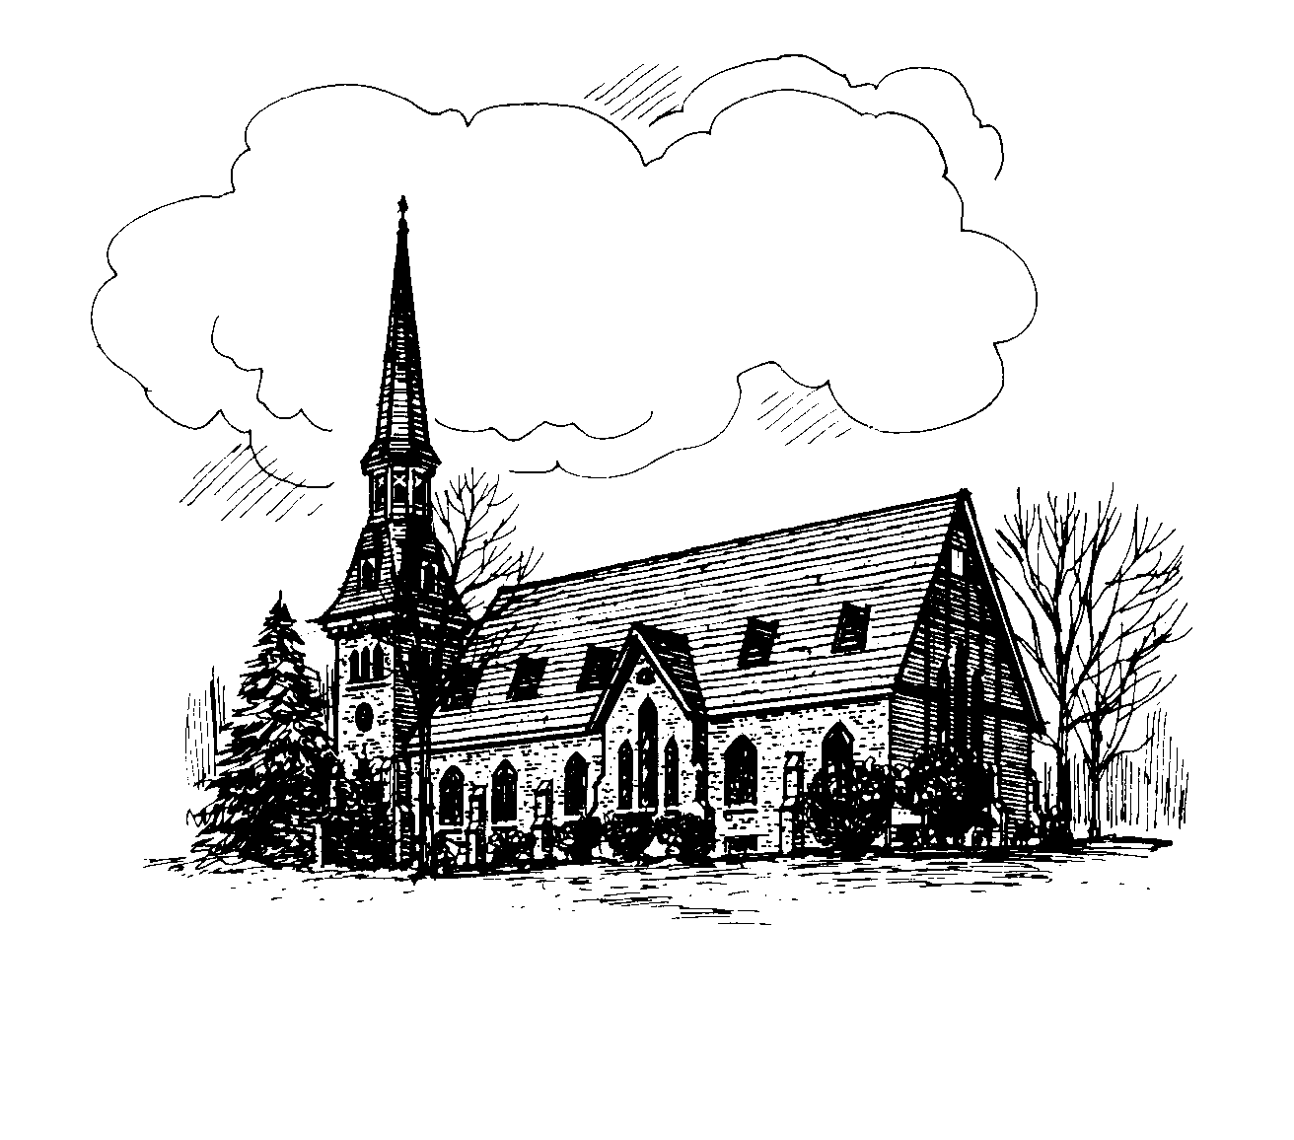

**CHURCH OF CHRIST UNITING**

A Congregation of the Presbyterian Church

and the

United Methodist Church

The Reverend Dr. Terrence O’Neill

Alice Mahardy, Organist & Choir Director

PO Box 896, Richfield Springs, NY 13439

**Online and In-person Worship**

Join us on **Sundays at 9:15 am.** All in-person worship services will be livestreamed to our church

**Facebook** page: **RS Church of Christ Uniting**

Go to [www.facebook.com](http://www.facebook.com) and put the above name in the search, or watch later on **YouTube**, by searching on **RS COCU**.

[www.rschurchofchristuniting.com](http://www.rschurchofchristuniting.com)

**Visiting PASTOR’S MESSAGE**

Greetings in the name of Christ!

While having owned a home that we renovated in 2010 Barbara and I have only recently moved to Richfield Springs where we are learning to enjoy what the region has to offer and find our way around relative to shopping, medical appointments, and the usual stuff of life.

We have had the opportunity to worship with Church of Christ Uniting on and off as we have been in town on Sundays but have been much more present since our move here in the fall of 2021 just before heading off to Florida where we winter in Punta Gorda on the west coast.

While the information below was printed in one of our recent worship bulletins, I thought I would offer it here again particularly for those who were not present a number of weeks ago and have not had the opportunity to “meet us.”

The Rev. Dr. Terrence (Terry) O'Neill is a graduate of Schenectady County Community College (AAS - Accounting), Siena College (BA - Accounting), Bangor Theological Seminary (M. Div.) and Drew University (D. Min.). Rev. O'Neill began his adult working life as a business manager for an electrical contractor and moved on to become a corporate accountant with the treasury department of the General Electric Company.

Terry married his high school sweetheart, Barbara Penn in 1973. Together they became active in the Rotterdam United Methodist Church where they soon became youth advisors and after considerable prodding by their pastor, they made the decision for Terry to enter graduate school to enter the ministry.

Upon completion of the three-year graduate program Terry served churches in Fort Ann, West Fort Ann, Ticonderoga, Albany, and Gloversville. He also served as the Methodist Chaplain at St. Peter's Hospital for seven years.

He and Barbara have no children but have been involved in the lives of their six nieces and nephews and now a great niece and nephews.

Barbara has been extraordinarily supportive of Terry's ministry, willingly sharing him with congregations. With a B.A. in Accounting from SUNY - Albany she is a retired professional woman having served Albany Medical College as the "Fiscal Coordinator for the Department of Medicine" then transitioned to The Department of Labor of NYS from which she retired.

Barbara is an avid knitter, quilter and crocheter and has produced hundreds upon hundreds of beautiful items many of which have been donated to church sales or otherwise given away. She has won numerous awards at the Altamont County Fair.

Terry enjoys building (in part or whole four houses, a garage and a few sheds or stables), and has refurbished a '67 Dodge, a '65 Corvair and is currently working on a '63 Corvette convertible "resto-mod."  Over his career he has published numerous magazine articles for clergy and legal journals, published numerous sermons and written one murder mystery novel.

That is a quick summary of what we’ve been up to prior to our coming here. Upon learning of Pastor’s Casey appointment to the Oneonta church I offered my services to lead worship over the summer knowing full well that the Presbyterian search can be lengthy and that filling a pulpit can be difficult over the summer as active clergy take vacation time and retired clergy can be busy filling in elsewhere. So, while not filling the traditional role of an interim pastor, I’m happy to offer the opportunity for worship through the summer months. May God add his blessings to a wonderful season.

Yours in Christ,

Terry

The Rev. Dr. Terrence O’Neill

There will be no nursery care, but there

are activity sheets at the usher’s table.

Donna Ross

Sunday Morning Ministries

For July

7/2. Reader. Mark Reardon

        Usher.   Jo-Ann Mead

        Coffee.   Linda Ellet’s

      Greeter.   Kate Huxtable

7/9. Reader.   Ross Jones

        Usher.     Carla Eckler

        Coffee.     Fred Eckler

        Greeter.   Donna Jones

7/16.   Reader.   Thomas Rhodes

           Usher.     FaithAnn Young

           Coffee.    Jo-Ann Mead

           Greeter.    Bill Stevens

7/23.    Reader.    Geri Erwin

            Usher.      Kate Huxtable

            Coffee.    Diane Butts

            Greeter.  Carla Eckler

7/30.    Reader.    Brian Howser

            Usher.      Donna Jones

            Coffee.    Sheryl Morris

            Greeter.    Diane Butts



We have separate lists. When you receive a message, call the next person. If you get an answering machine, please leave a message, and call the next name on your list.

PRAYER CHAIN – List 1:

Linda Ehler 315-858-1833

Susan Sheldon 315-868-8005

Carrie Gardner 315-858-0634

Geri Erwin 315-858-2103

Rowena Robertson 315-858-0652

Carol Simpson 315-868-0319

PRAYER CHAIN – List 2:

Patti Lou Leopold 315-858-2706

Donna Jones 315-796-1644

Nancy Strongreen 315-858-9483

Kate Huxtable 315-858-1566

Shirley Dreis 315-858-0667

**New prayer list request policy set up by the

Board which was put into effect June 10th. To have a name added to the prayer list fill out a prayer request form and hand in to the Church Secretary. The name will stay on the list for 4 weeks but another pray request can be handed in to continue.

*******************

**2023 Bake Sale – Another Success**

We thank each and every one of you who contributed to our Craft Festival Bake Sale. We hear all the compliments that you deserve – about how delicious the baked goods are and what a wonderful selection we offer. One woman came back just to tell us that our Bake Sale is the best she has ever attended. This year we raised $1,030. The credit is yours. You are treasures and very much appreciated.

Rowena Robertson & Geri Erwin

Kristen Culkin & Katie Culkin



Please take a look at the sign-up sheet in the fellowship room and pick a Sunday to provide flowers. You have 1 or 2 types of flowers and don’t feel you have enough to make a bouquet. (Check with Rowena and she will help you put it together if you like). Two of you may  like to make a bouquet together.  A reminder: Price Chopper usually has three bunches for $15, I will usually take 4 bunches to fill the vase I use (under the big sink in the Church kitchen).

A beautiful arrangement was provided for Sunday June 18th  by Geri Erwin in memory of Patti Mitchel.

Thank you Geri.

And finally, a special thank you goes out to the anonymous donor who provided me with the monetary gift to make two lovely arrangements for the Altar.

It’s nice to have friends who want to help.

Thanks,

Rowena

315-858-0652

Wishes to….

7/4 Michele Lee Sheldon

7/5 Bill Huxtable

7/6 Margaret Goodrich

7/7 FaithAnn Young

7/7 Nancy Beadle

7/9 Lani King

7/9 Nancy Dreis Fuller

7/12 Mary Stevens

7/13 Kaitlyn LaGrange

7/19 Wayne Thomas Sheldon

7/21 Marston Erwin

7/22 Emma Boss

7/26 Lynae Wyckoff

7/29 Mathew Belcher

To..

7/4 Heidi & Stephen Bond

7/12 John & Mary Wilde

7/13 Donna & Ross Jones

7/14 Sally & Tom Crohan

7/14 Tom Worobey & Katie Bond Worobey

7/19 Marjorie & Walter Hubiak

7/21 Linda & David Ehlers

7/26 Alice & Bill Mahardy

7/30 Rick & Candace Huxtable



The Chancel Choir will be taking a well-deserved

Vacation from July 1 to mid September. Many thanks

To all the members for their dedication and commitment. I certainly appreciate it. If anyone would like to provide special music (either you or someone you know) please let me know. Singers or instrumentalists are welcome.

Alice Mahardy- Choir Director

***Second Mile Giving*** for July is the



"The Richfield Springs Community Center holds programs for all ages and rents the facility for personal, business, and nonprofit use. Our mission is to empower individuals with educational, emotional and social life skills through effective programming, enabling the family unit to become stronger, ultimately creating a thriving community."

Located at 6 Ann Street Richfield Springs, NY 13439

315-858-3200



**July 20th Women’s Guild picnic to be held at

Linda Watkins’ to beginning at

6 P.M. You are requested to bring a

dish to pass and let Linda know by

July 18th if you will be attending so

she can have everything sent up to

accommodate us all. Linda’s phone

number is 315-868-1703 and her

email address

[lpwatkins@yahoo.com](mailto:lpwatkins@yahoo.com). Please

contact her in whichever way is

convenient for you.

**August 20th Summer Picnic @ Baker Beach

Meeting House (white building)

Come join us at Noon for food,

fun, and fellowship. More details to

be in the August newsletter.

**September 21 The Annual Food Pantry

Shower at the church. Linda

Ehlers will be the host.

Please bring a dish to pass for

everyone to enjoy. Also bring

canned goods or other food

staples to donate to the Food

Pantry. A list of items needed

will be provided later.

**October 7th 3rd Annual Fall Craft Fair



The Women's Guild will be enjoying a well-deserved picnic at our next meeting to evaluate this year's very successful Craft Festival. Linda Watkins has graciously invited us to her home for this event to be held on Thursday, July 20, at 6pm. Please bring a dish to pass. Please let Linda know by July 18th whether you will be going, so she can set up accordingly. Her phone number is 315-868-1703. You can call or text her or send her an email at: lpwatkins@yahoo.com.

The Women's Guild will be hosting a Bridal Shower on Friday, July 14th. Details will be sent to the Guild in a separate email and/or text.

As usual, there will be no meeting in August. We will get together again on Thursday, September 21, at 6pm, when we have our Annual Food Pantry Shower at the church. Linda Ehlers will be the host. Please bring a covered dish to enjoy together. Bring canned goods or other food staples to donate to the Food Pantry. A list of items needed will be provided later.



If any of your children are interested in attending camp this summer, please contact Donna Jones for more information at: 315-796-1644. The Church and the Women's Guild help pay for this so we hope you'll take advantage of this opportunity.

~~~~~~~~~~~~~~~~~~~~~~~~~~~~~~~

COCU Board meets

Tuesday, July 11th at 6:30 p.m.



On June 4th we were happy to share a celebratory brunch with Pastor Casey and Heather following our Sunday Worship Service.

We had a wonderful time celebrating Casey's recent Ordination and were happy to celebrate their time with the COCU family. We wish them well with their new church family at the United Methodist Church in Oneonta and want to congratulate them on the purchase of their new home.

Their new address is: 41 Ford Ave, Oneonta NY 13820

I'm sure they'd love to hear from you!

Continues to serve

Tuesdays and Thursdays each week

10 am - Noon normally.

2nd and 4th Saturdays of the month

11 am – Noon

Volunteers are always welcome to help with

food deliveries, call Nicole Martinson @

850-554-8537 to inquire.

~~~~~~~~~~~~~~~~~~~~~~~~~~~~~~~

