**Good News Ambassador**

**July 2024**

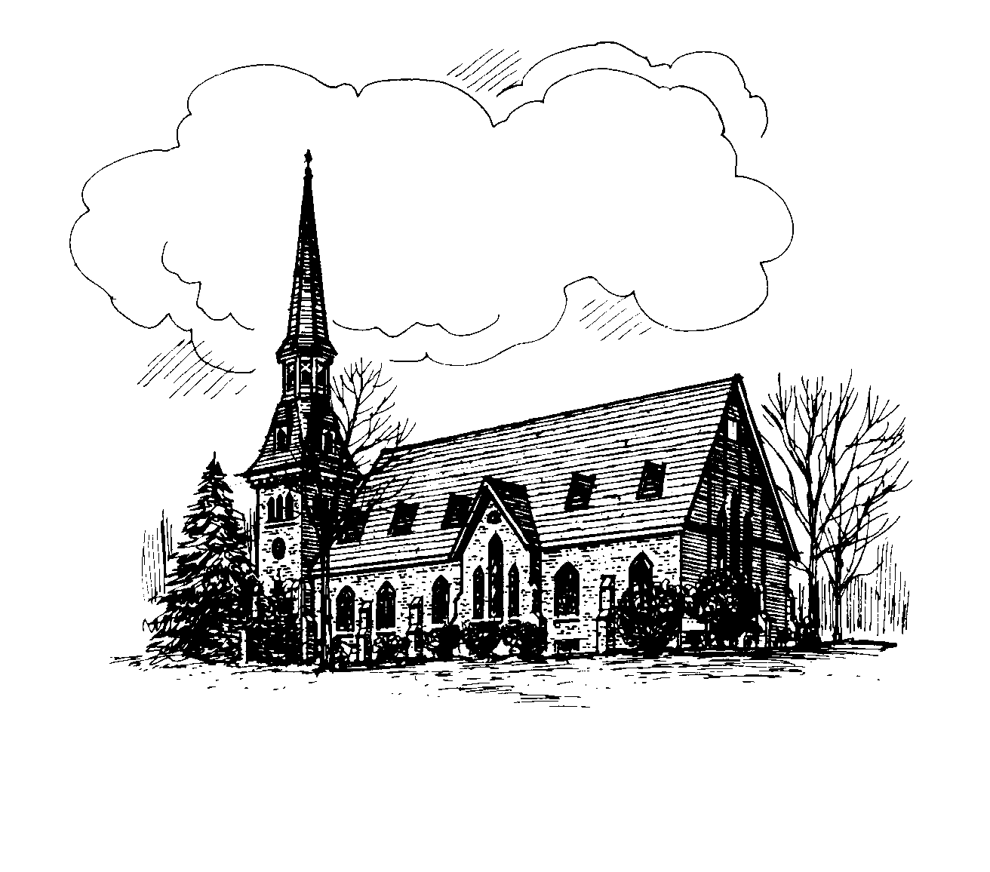

**CHURCH OF CHRIST UNITING**

A Congregation of the Presbyterian Church

and the

United Methodist Church

Pastor Christine Mitchell

Alice Mahardy, Organist & Choir Director

PO Box 896, Richfield Springs, NY 13439

**Online and In-person Worship**

Join us on **Sundays at 9:15 am.** All in-person worship services will be livestreamed to our church

**Facebook** page: **RS Church of Christ Uniting**

Go to [www.facebook.com](http://www.facebook.com) and put the above name in the search, or watch later on **YouTube**, by searching on **RS COCU**.

[www.rschurchofchristuniting.com](http://www.rschurchofchristuniting.com)



**PASTOR’S MESSAGE**

Pastor Chris is scheduling times to meet with church members if they so desire. This is a wonderful way to get to know her and for her to get to know you better.  If you are interested.  There will be sign-up sheets in the fellowship hall.  She has offered the opportunity to meet her at the church or at your home.  She just asks that you please make sure she has your address to ensure she knows where to go.

Sunday Morning Ministries

For July

7/7 Reader Brian Howser

Usher Jo-Ann Mead

Greeter Kate Huxtable

Coffee Carol Simpson

7/14 Reader Ross Jones

Usher FaithAnn Young

Greeter Donna Jones

Coffee Linda Ehlers

7/21 Reader Geri Erwin

Usher Carla Eckler

Greeter Diane Butts

Coffee Fred Eckler

7/28 Reader Mark Reardon

Usher Kate Huxtable

Greeter Bill Stevens

Coffee Jo-Ann Mead



We have separate lists. When you receive a message, call the next person. If you get an answering machine, please leave a message, and call the next name on your list.

PRAYER CHAIN – List 1:

Linda Ehler 315-858-1833

Susan Sheldon 315-868-8005

Carrie Gardner 315-858-0694

Geri Erwin 315-858-2103

Rowena Robertson 315-858-0652

Carol Simpson 315-868-0319

PRAYER CHAIN – List 2:

Donna Jones 315-796-1644

Nancy Strongreen 315-858-9483

Kate Huxtable 315-858-1566



Dayton Kane Fred Gardner

Tom Worobey Les Olmstead

Dan LaBarge Cliff Oakes

Mariel Richardson



Remember that the sign-up sheet is in the fellowship hall.

Altar flowers can be and are more than mere ornaments. They are the expression of our love for God as well as a means of glorifying his name in all the earth (Psalm 9:9). We therefore thank you for your willingness to serve God in this meaningful way.



7/5 Bill Huxtable

7/6 Margaret Goodrich

7/7 Nancy Beadle

7/7 FaithAnn Young

7/9 Lani King

7/9 Nancy Dreis Fuller

7/12 Mary Stevens

7/13 Kaitlyn LaGrange

7/19 Wayne Thomas Sheldon

7/21 Marston Erwin

7/22 Emma Boss

7/26 Lynae Wyckoff

7/29 Mathew Belcher



7/4 Heidi & Stephen Bond

7/12 John & Mary Wilde

7/13 Donna & Ross Jone

7/14 Sally & Tom Crohan

7/14 Tom Worobey & Katie Bond Worobey

7/19 Marjorie & Walter Hubiak

7/21 Linda & Davie Ehlers

7/26 Alice & Bill Mahardy

7/30 Richard & Candace Huxtable

***Second Mile Giving*** for July is the

***Shriners Hospital for Children***

**Donors’ gifts make extraordinary things possible for patients at Shriners Children’s. With personalized, compassionate specialty care, they can do more and dream bigger – all thanks to donors like you!**





The Women's Guild will be enjoying a well-deserved picnic at our next meeting. Linda Watkins has once again graciously invited us to her home for this event to be held on Thursday, July 18, at 6pm. Please bring a dish to pass. Please let Linda know by July 17th whether you will be going so she can set up accordingly. Her phone number is 315-868-1703. You can call or text her or send an email to: [lpwatkins@yahoo.com](mailto:lpwatkins@yahoo.com).

As usual, there will be no meeting in August. We will get together again on Thursday, September 19, at 6pm when we will have our Annual Food Pantry Shower at the church. Donna Jones will be the host. Please bring a covered dish to enjoy together. Bring canned goods or other food staples to donate to the Food Pantry. A list of items needed will be provided at a later date.



**Craft Festival**

The Craft Festival Committee would like to thank everyone for all their donations, baking, and hard work to make this year’s Craft Festival the success it is. We couldn't do any of this without you, and we want you to know how much you're appreciated. We are blessed to have such talented people on our team and, I must add, some of the best bakers around! God bless you all!



Choir News

The Chancel Choir's last Sunday will be July 7. They will be on vacation for the summer and will begin a new season in mid-September. I am extremely appreciative of their dedication and willingness to help provide music for worship. If anyone is interested in providing special music for any summer Sunday, please contact Alice Mahardy. We welcome singers and/or instrumentalists.

**News from the Governing Board** Regarding the mailing of COCU’s monthly newsletter, in 2021 the process began to continue our mission to be as fiscally responsible as possible. Many now receive the newsletter via e-mail, saving COCU labor and postage expenses. At the May Governing Board meeting it was decided that we will no longer be mailing the newsletter to anyone having an e-mail address-- -- beginning with the July newsletter. If you are currently getting your newsletter mailed to you and you have an e-mail address, please contact Marie, COCU Secretary to be added to the monthly e-mail list. The church’s e-mail address is [COCU@verizon.net](mailto:COCU@verizon.net)



**RS Church of Christ Uniting**

**is sponsoring a Yankees Game Bus Trip**

**”Families Welcome”**

Saturday, August 10th Yankees vs Texas Rangers “Military appreciation Day”

Price is $138.00 per person

Price includes: Transportation (Hale 56-pass motorcoach) Water/Snacks on the bus Yankees tickets- section 308 Itinerary: 6:10 am Begin check in 6:30 am Departure 11:00 am Game time Bus departs for home after the Game ends 9:30 pm Approximate return to Richfield MEETING POINT: School Parking Lot

93 West Main St Richfield Springs, NY

Call FaithAnn Young to reserve and purchase tickets at 315-858-2657 One rest stop there and one rest stop back. Early enough arrival for lunch & souvenir Shopping; visit Monument Park inside the Stadium.

Doors open at 11:30am. First 18000 fans in the gate, age 21+ receive a complimentary Yankee camo ball cap.



July 7th Pastor Christines first service at

COCU

July 9th Next Borad of Directors Meeting

in the Fellowship Hall beginning at

7:50pm.

July 14th A special welcome reception for

Pastor Chris and her Family to follow

The Sunday worship service in the

fellowship hall. We hope all will join in

to make her and her family feel welcome.

Breakfast will be served (fruit, muffins,

French toast casserole, coffee, and juice)

August Church picnic will be scheduled. Details

will be in the August newsletter and in the

weekly bulletin as they become available.

We hope you all will be available to come.

August 21st Senior Picnic @ Glimmerglass Park

Call Otsego County Council of Senior

Citizens to place your reservation by

August 15th (607-547-7232)

Transportation is available upon

request.



Continues to serve Tuesdays and Thursdays each week 10 am - Noon normally. 2nd and 4th Saturdays of the month 11 am – Noon Volunteers are always welcome to help with food deliveries, call Nicole Martinson @ 850-554-8537 to inquire. Donations can be sent to

The Richfield Springs Food Pantry, P.O. Box 140

Richfield Springs, NY 13439