**Good News Ambassador**

**September 2024**

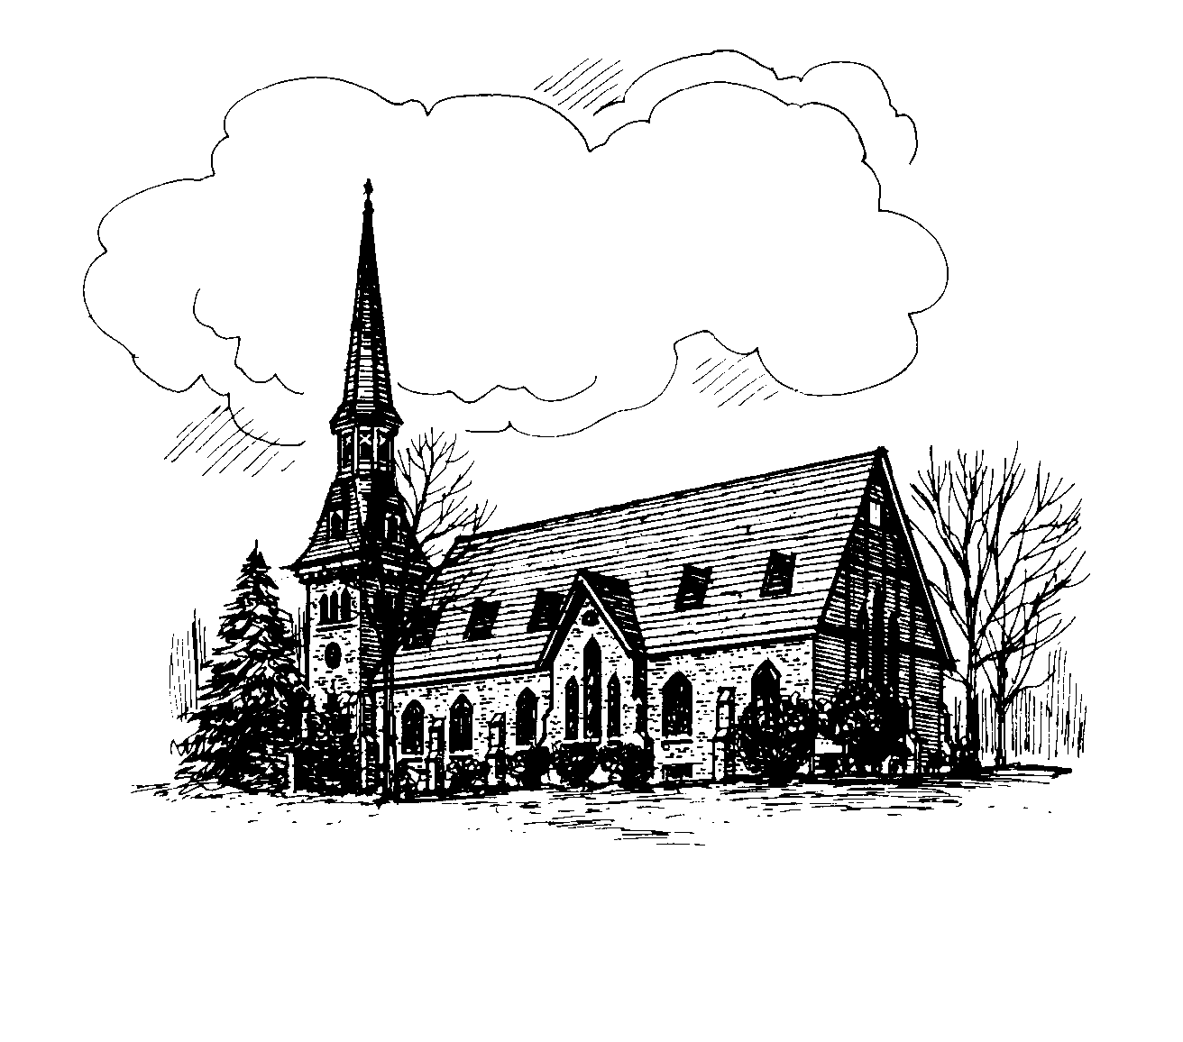

**CHURCH OF CHRIST UNITING**

A Congregation of the Presbyterian Church

and the

United Methodist Church

Pastor Christine Mitchell

Alice Mahardy, Organist & Choir Director

PO Box 896, Richfield Springs, NY 13439

**Online and In-person Worship**

Join us on **Sundays at 9:15 am.** All in-person

worship services will be livestreamed to our church

**Facebook** page: **RS Church of Christ Uniting**

Go to [www.facebook.com](http://www.facebook.com) and put the above name in the search, or watch later on **YouTube**, by searching on **RS COCU**.

[www.rschurchofchristuniting.com](http://www.rschurchofchristuniting.com)

**PASTOR’S MESSAGE**

*“4Hear, O Israel: The Lord is our God, the Lord alone. 5 You shall love the Lord your*

*God with all your heart, and with all your soul, and with all your might. 6 Keep these words that*

*I am commanding you today in your heart. 7 Recite them to your children and talk about them when you are at home and when you*

*are away when you lie down and when you rise.” (Deuteronomy 6:4-7)*

Hard to believe summer is behind us, and

the cool crisp air of fall is coming near. The Pumpkin spice is out, and Halloween candy

is lining the shelves, which only means one thing….

The official start of the new school year, and the new Sunday School year!!

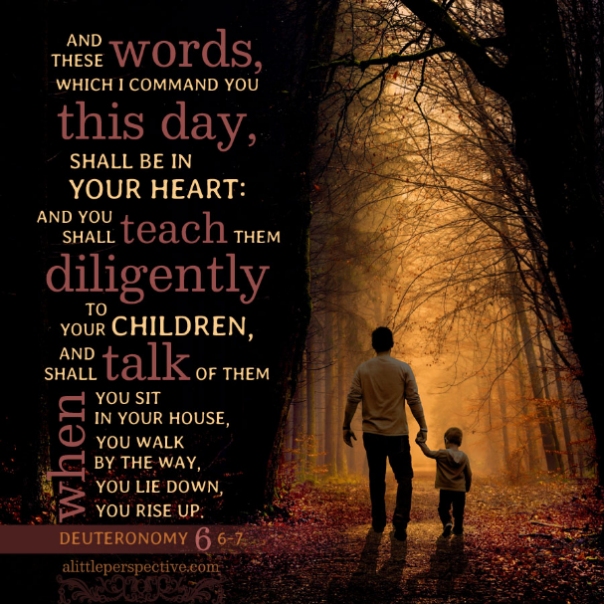

That’s right, it's back to church, Sunday September 8th. Sunday School will begin during church. Our young disciples will be offered the opportunity to leave after their time with me, to head off to Sunday School. In addition, on the 8th after church during coffee hour, we will have some tables set up and information sheets/signup sheets for opportunities we have for you to be involved in the church. Some take very little time; others might take a bit more. I encourage you to walk around and speak with the chairperson or the leader of the groups and find out what they are looking for you to do as part of a committee, ministry, mission, or leadership positions.

We will begin a Membership Class on Sunday, September 15th after worship, and coffee hour after church. We will meet for 4 weeks, and then on October 6th on World Communion Sunday we will welcome our new members in church. We currently have four people signed up to attend, but anyone who would like to join us in this class is welcome to come on the 15th to begin the membership process.

Please keep our youth who will begin their journey of confirmation. Each of the boys will be asked to approach someone in the church that is unrelated to them, to become a mentor for them through this journey. The job of the mentor is to keep the boys in prayer, meet with them periodically to see how they are doing, answer any questions they might have, build a relationship with them, and teach them about their faith both in practice and in friendship. This person needs to be Safe Sanctuaries trained, if you have not taken Safe Sanctuaries, please let me know, as we will be having a class coming up soon here at church so you will have an opportunity to take the training. This would also include a background check. They will be confirmed in church on June 8th during our Pentecost Service.

Here is to a great school year for our children, youth, and teachers within our congregation. Lord, we ask that you bless each student, teacher, administrator, whoever might touch the life of a child this school year. Let them shine your light, let their faith help them through those difficult days, being reminded that you knew them in the womb before they were born and that even when they think they are not doing a good job, they are doing what you called them to do and for that, you will

be blessed and be their guide.

~Pastor Chris  

Sunday Morning Ministries

for the month

September 1st

Reader Ross Jones

Usher Jo-Ann Mead

Coffee Diane Butts

Greeter Donna Jones

September 8th

Reader Linda Ehlers

Usher FaithAnn Young

Coffee Carol Simpson

Greeter Kate Huxtable

September 15th

Reader Brian Howser

Usher FaithAnn Young

Coffee Linda Ehlers

Greeter Bill Stevens

September 22nd

Reader Geri Erwin

Usher Carla Eckler

Coffee Fred Eckler

Greeter Donna Jones

September 29th

Reader Linda Ehlers

Usher Kate Huxtable

Coffee Sheryl Morris

Greeter Bill Stevens

Prayer Chain:

Would YOU like to volunteer to join the Prayer Chain Ministry?

**The prayer chain of COCU consists of two teams of people who have volunteered to pray for all those brought to our attention, those who are ill or in difficult situations. When one would like to ask for prayer, he/she calls the first name on both lists or call one and ask to have the other called,**

**(give a name and a brief description of the need, remembering to honor the feelings and privacy of the one being prayed for) then those people call the next person on their “chain” and so forth. If there is no answer, leave a message and call the next person listed.**

Again, **if you would like to be a part of this ministry, see either of us in church or call; Linda Ehlers 315- 858- 1833**

**or Donna Jones 315- 796- 1644.**



Dayton Kane Fred Gardner

Tom Worobey Les Olmstead

Dan LaBarge Cliff Oakes

nnnnn 

Remember that the sign-up sheet is in the fellowship hall.

Altar flowers can be and are more than mere ornaments. They are the expression of our love for God as well as a means of glorifying his

name in all the earth (Psalm 9:9). We therefore thank you for your willingness to serve God in

this meaningful way.

9/5 Samantha Jasso

9/7 Thomas Twomey

9/10 Gary Southard

9/10 Gailyn Dyn

9/13 Maibel Buck-Homer

9/15 Arnold "Gene" Simpson

9/18 Carla Eckler

9/18 Kevin Mahardy

9/19 Charlotte Plows

9/19 Roger Vaughn

9/20 Ashlyn Wolfe

9/20 Sheryl Morris

9/24 Candice Domion

9/25 Fred Eckler

9/28 Melissa Belcher

9/29 Abigail Matteson



9/6 Michael & Connie Domion

9/20 Carla & Fred Eckler

9/23 Tyler & Tayor (Hallberg) Coughlin

9/29 Melanie & Don Bruce

***Second Mile Giving*** for September is

The Ronald McDonald House Charities

## 

## Search: ronald mcdonald house charities ...

## **Our Mission**

**At RMHC, we provide essential services**

**that remove barriers, strengthen families,**

**and promote healing when children need healthcare.**



SEPTEMBER GUILD MEETING

CHANGE OF LOCATION

The September meeting on Thursday, September 19, at 6pm will be at the Community Center on 6 Ann Street due to the Rummage Sale being all setup for the next day. This will be our Annual Food Pantry Shower. Donna Jones will be the host. Please bring a covered dish to enjoy together. The following are the most needed items requested by the Food Pantry: assorted boxed cereals, peanut butter, tuna fish, any canned fruit except apple sauce, any canned vegetable except green beans, assorted dried pastas, spaghetti sauce and pancake syrup.

FALL CRAFT FAIR

The 4 th Annual Fall Craft Fair at Cullen Pumpkin Farm, sponsored by the COCU Guild, will take place on Saturday, October 5th, from 10 am – 4 pm, at 587 Cullen Road. Richfield Youth Sports will be selling hamburgers, hot dogs, hot sausage, French fries, and drinks to benefit their fundraising efforts. The Guild ONCE AGAIN appreciates the Shypski family for giving us this opportunity. We hope to see you all there.

Update

The Guild’s first effort of hosting a community bus trip was successful. We made it to Yankee

Stadium and back safely with an almost full bus. We witnessed a home run, honored our veterans, and received a complementary hat

and the Yankees earned a bug win! Seniors and families came from a wide area outside

of Richfield Springs and we had a beautiful sunny day.



Choir News

The Chancel Choir will begin the new season on Sunday, September 15 Please meet in the sanctuary at 8:45am. Rehearsals will begin after the service.

New members are always welcome. Contact me or any member of the choir.

Alice Mahardy



**Fall Classes will begin Sunday September 8th we’ve ordered the new curriculum, and it looks like a fun way to learn about God. We’ll be learning about Creation, Noah, Joseph and more of the Old Testament characters. They had a lot to learn from God and their stories will be an interesting way for us to learn also, together. Questions call Donna 315 796 1644.**

**See you in Church!!**

**N**  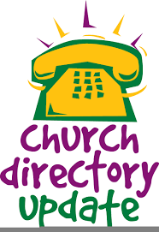

It’s been a tradition to have a new church directory produced every 5 years—the last one being 2019. Carla Eckler is, once again, spear heading the publication of a 2024 Church Directory. It will contain the usual photos as well as the handy roster section in the back listing names with mailing/physical addresses and phone number(s). You do not have to have your photo taken to be in the roster. Photo date is Saturday, October 19 from 10 a.m. to 2 p.m. All photos will be taken in 5-minute increments. Another person will be onsite to show photos on a laptop so that one photo can/will be selected for inclusion in the directory. Additional photos can be ordered at that time, or they can also be viewed and ordered on their website. More info on the website later.

• Starting Sunday, September 1 through Sunday, October 6 there will be a sign-up sheet on the table in the Fellowship Hall

listing appointment time slots as well as

asking how many will be in the photo.

• The first week in December is the target date for delivery of photos for those ordering

them---in time for Christmas giving!!

• A flyer listing photo package prices will be on the table.

• Additionally, a form will be on the table requesting the above info for the handy roster section in the back of the directory. • A file folder to conveniently place these forms in

will be on the table as well. Carla will periodically collect these sheets in order to tabulate the information for the directory in a timely manner. • Photos will be taken by BJK Photos out of Oneida, NY. Our local school uses them for their student photos. They come highly recommended!!! Questions?

Please just ask!!! Carla is using the Guild’s

e-mail address for all matters pertaining to

the directory: [cocuguild@yahoo.com](mailto:cocuguild@yahoo.com);

call 315-858-1451.

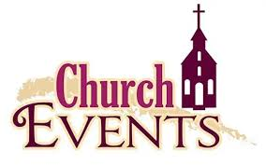

--**September** **19th** Women’s Guild meetingto be held at the Community Center on 6 Ann Street due to the Rummage Sale being all setup for the next day. This will be our Annual Food Pantry Shower. Donna Jones will be the host. Please bring a covered dish to enjoy together. The following are the most needed items requested by the Food Pantry: assorted boxed cereals, peanut butter, tuna fish, any canned fruit except apple sauce, any canned vegetable except green beans, assorted dried pastas, spaghetti sauce and pancake syrup.

**--September 20th** Back by popular demand.

The Fall Rummage Sale is back and will take place on Friday, September 20, from 9:00 a.m. to 5:00 p.m. A bag sale will be from 3 p.m. to 5:00 p.m. Fill a bag for $2.00. Linda Watkins will, once again, head up this well received church fundraiser. Start cleaning those closets!!! • Items can be brought in as early as Sunday, September 15 and placed in the Winter Chapel. • Deadline for dropping off items is Thursday, September 19 at 12 Noon. • Set up will begin Tuesday, September 17 at 12 Noon—after the Food Pantry closes. • Volunteers are needed! Stop in and lend a helping hand even if it is just for an hour or two.



Continues to serve Tuesdays and

Thursdays each week 10 am – Noon

normally. 2nd and 4th Saturday of the month

11 am – Noon Volunteers are always

welcome to help with food deliveries, call

Nicole Martinson

@ 850-554-8537 to inquire.

Donations can be sent to

The Richfield Springs Food Pantry,

P.O. Box 140 Richfield Springs, NY 13439