**Good News Ambassador**

**April 2025**

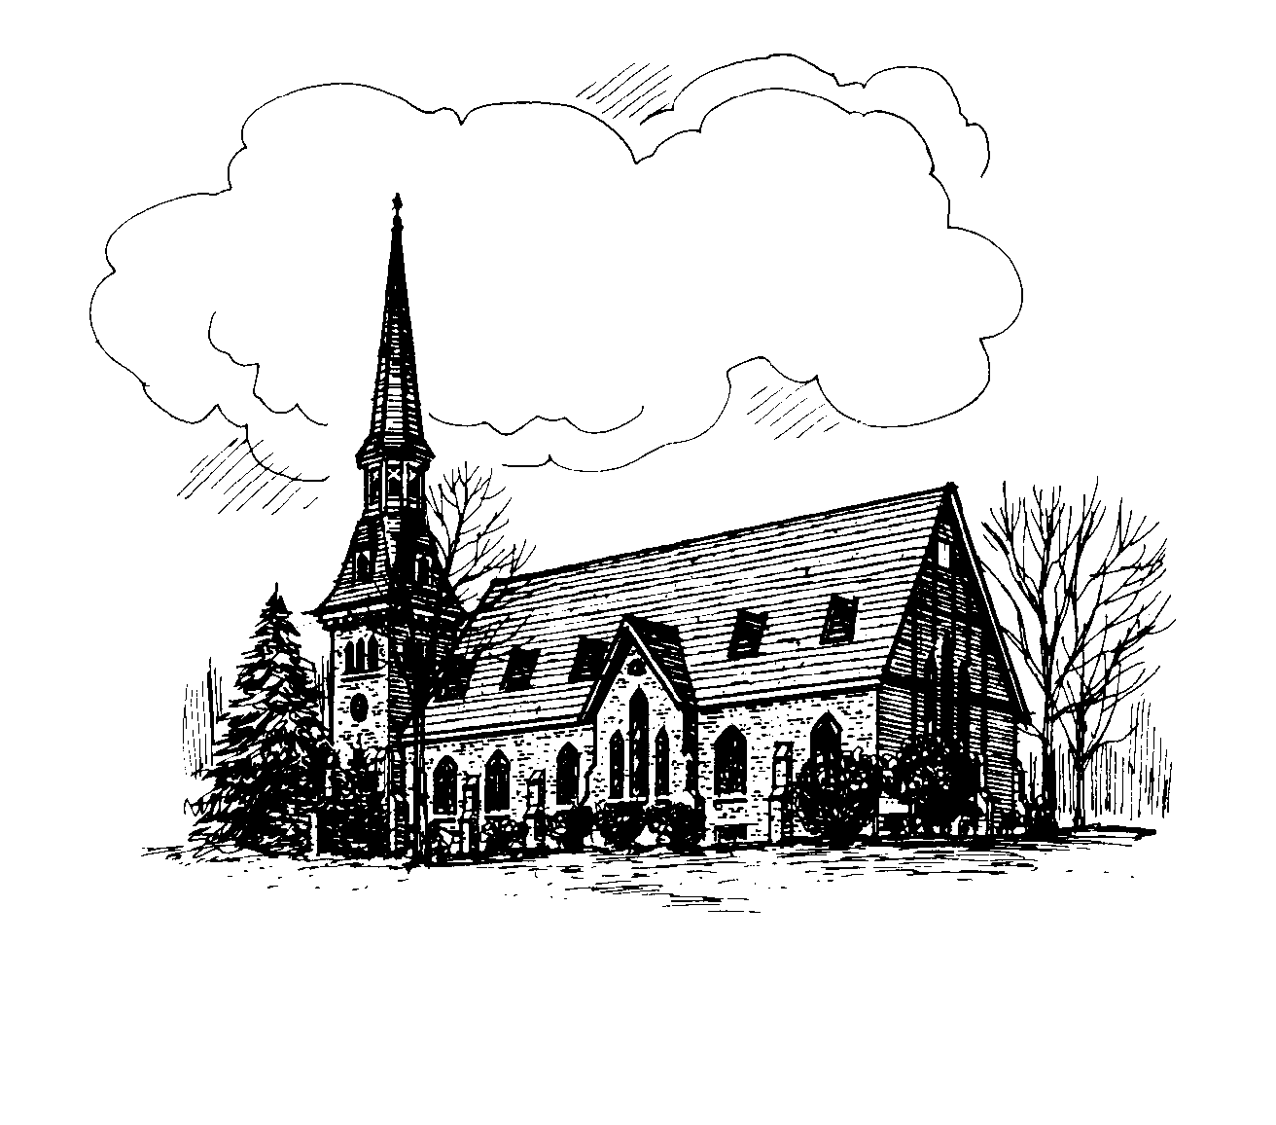

**CHURCH OF CHRIST UNITING**

A Federated Congregation of

Presbyterian Church USA

and the

United Methodist Church

Rev. Christine Mitchell, Pastor

22 Church Street,

Richfield Springs, NY 13439

All worship services will be live on our

Facebook page: RS Church Christ Uniting

or on our website:

https://rschurchofchristuniting.com/worship/

**Springtime and the Promise of New Life**

As April arrives, the world around us begins to awaken. The days grow longer, the air carries the scent of fresh earth, and signs of new life emerge everywhere—buds on trees, flowers pushing through the soil, and birds singing joyfully. Spring reminds us that even after the longest, coldest winter, renewal is always possible.

This theme of new life is at the heart of Holy Week, a journey from darkness to light, from sorrow to joy. We invite you to walk this sacred path with us, as we remember Jesus' sacrifice and celebrate His triumphant victory over death.

### Palm Sunday – Marching Toward Hope

Join us on **Palm Sunday at 9:15 AM** as we commemorate Jesus’ triumphant entry into Jerusalem. The crowds waved palm branches and shouted, “Hosanna!” welcoming the Messiah with joy and expectation. Yet, as we know, the week ahead would take a dramatic turn. This service invites us to reflect on the contrast between celebration and sacrifice, joy, and suffering, as we prepare our hearts for Holy Week.

### Maundy Thursday – A Table of Grace

On **Maundy Thursday at 7:00 PM**, we will gather for a Communion Service, remembering the Last Supper Jesus shared with His disciples. On that night, Jesus knelt to wash their feet, teaching them the power of humility and love. He then broke bread, offering Himself fully for the salvation of the world. As we share in this sacred meal, we are reminded of Christ’s great commandment: to love one another as He has loved us.A close-up of a chalice

### A group of people on a cross AI-generated content may be incorrect.Good Friday – The Depth of Love

On **Good Friday at 7:00 PM**, we gather for our solemn **Good Friends Service**, a time of reflection on Jesus’ suffering and crucifixion. This is a night of deep reverence as we remember the cost of grace. In the quiet of the cross, we sit with the weight of Christ’s love—a love so profound that He willingly gave His life for us.

### Easter Sunday – The Joy of Resurrection!

Then, on **Easter Sunday at 9:15 AM**, we will rejoice together in the miracle of resurrection! The stone is rolled away, the tomb is empty, and Christ is risen! Death does not have the final word—life does. Love does. Hope does. Come and celebrate the victory of new life in Christ, a promise that extends to us all.A group of crosses in a cave

This Holy Week, may we open our hearts to the beauty of the season and the profound truth of our faith. Just as spring brings renewal to the earth, Christ brings renewal to our souls. Let us walk this journey together, embracing the love, sacrifice, and victory that Easter brings.

Blessings to you this season, and we look forward to worshiping with you!

Pastor Chris



**Sunday School News**

**We will be discussing Palm Sunday**

**And Easter in early April. There will be no class on Easter Sunday so all families can attend worship together. There will be an activity sheet for students on the usher’s table on that Sunday. The 27th of April we will be discussing “Doubting Thomas”.**

**As always, guests are most welcome, so invite a friend.**

Also, we need more teachers, helpers, or assistants. If you can give a Sunday a month to help it would be very much appreciated. Let Pastor or one of the teachers know. Questions or concerns call Donna at 315-716-1644.



Sunday Morning Helping Hands

**April 6th**

Usher Jo-Ann Mead

Reader Ross Jones

Greeter Donna Jones

Coffee Carol Simpson

**April 13th**

Usher Geri Erwin

Reader Mark Reardon

Greeter Bill Stevens

Coffee Sheryl Morris

**April 20th**

Usher Kate Huxtable

Reader Linda Ehlers

Greeter Bill Stevens

Coffee Diane Butts

**April 27th**

Usher Carla Eckler

Reader Melissa Blecher

Greeter Kate Huxtable

Coffee Fred Eckler



**Altar Flowers:**

Thank you to Don and Sue Sheldon for the beautiful altar flowers in memory of their son Eric. And we would like to thank the family of Dan LaBarge for their flower arrangements in memory in Dan’s memory.

**Easter flowers:**

A sign-up sheet is in the fellowship hall, please sign up early so our secretary has time to add to the bulletin. Flowers should be to the church no later than noon on April 19th. You may also call Rowena at

315-858-0652

Prayer Chain Ministry!

To start the prayer chain by calling:

**Linda Ehlers:** 315-858-1833

**Donna Jones:**  315-796-1644

*If you would like to become part of the prayer chain call one of the numbers above.*

**\*REMEMBER\***

Save room for the drive thru

Chicken BBQ on Saturday April 5th

4p.m. until Sold Out.

$10.00 for half chicken

$15.00 for full dinner



Dayton Kane Fred Gardner

Bill Burdick Cliff Oakes

Staci Earl Tim Snyder

Richard Bowser Christine Roe

Please make Pastor Chris or Church Secretary aware of any updates.



***Second Mile Giving for April***

**One Great Hour of Sharing**

One Great Hour of Sharing (OGHS) gives us a way to share God's love for justice. In fact, OGHS is the single largest way Presbyterians come together to work for a better world. Through OGHS, you provide safety, sustenance, and hope to people who lack access to food, clean water, sanitation, education, and opportunity.



4/1 Mary Beth Kearney

4/1 Katelynn Bond Worobey

4/2 Cameron Boss

4/2 Anna Hawkes

4/4 Emily Bond

4/8 Carrie Gardner

4/10 Diane Vaughn

4/10 Maureen Kennedy

4/12 Priscilla Edick

4/14 Lois Schoenlein

4/14 Linda Ehlers

4/14 Jessica Ann Klem

4/24 Geri Erwin

4/29 Ashley Lindsay

4/30 James Watkins



4/18 Rev. Mark & Myrna Ioset

***Church Calendar of Events:***

**April 5:** Brooks’ Drive Through Chicken BBQ, 4 PM until sold out

**April 13:** Palm Sunday service, 9:15 AM

**April 13***:* Annual Bread Auction, after church service

**April 16:** Guild Meeting, 6 p.m.

**April 17**: Maundy Thursday service, 7 PM

**April 18:** Good Friday service, 7 PM

**April 20:** Easter Sunday service, 9:15 AM

**May 12:** Women’s Appreciation Dinner, 6 PM

**May 15 & 16:** Spring Rummage sale (hours forthcoming)

**June 14**: 44th Annual Friendship Craft Festival, 9 AM - 3 PM

**September 26**: Fall Rummage Sale (hours forthcoming)

**October 4:** 5th Annual Fall Craft Fair, Cullen Pumpkin Farm, 10 AM - 4 PM

**November 15**: Luncheon/Bake

Sale/Craft Corner, 10 AM - 2 PM

And a special note from

the Pastor:

Pastor Chris is available in the church office on Tuesdays from 10 a.m. to

1 p.m., by appointment, or at home visits. Pastor practices her sabbath on Fridays and should be contacted for emergencies only.

If you would like to schedule a visit, please don’t hesitate to reach out to her.

She also offers monthly in-home communion visits and is available for Spiritual counseling and pastoral care.

**FOOD PANTRY DONATIONS**

It gives us here at the Church of Christ Uniting considerable pride to host the local Food Pantry. If you are so inclined to support this ministry, they are always in need of food staples such as cereal, pasta, canned vegetables, and fruit. There is a basket located in the sanctuary for this purpose. Or consider stopping by the church on Food Pantry days: Tuesdays and Thursday from 10 AM to 12 Noon as well as the 2nd and 4th Saturdays from 11 AM-12 Noon.



Volunteers are always welcome to help with food deliveries, packing bags, etc., call

Connie Olsen at 607-267-2190 to inquire.

Monetary donations can be sent to:

The Richfield Springs Food Pantry,

P.O. Box 140 Richfield Springs, NY 13439